**Waste management system diagrams.**

**Sequence diagram**

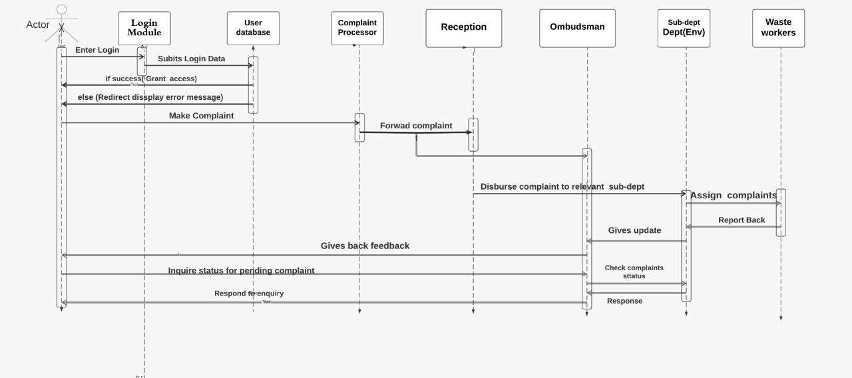

**Use case diagram**

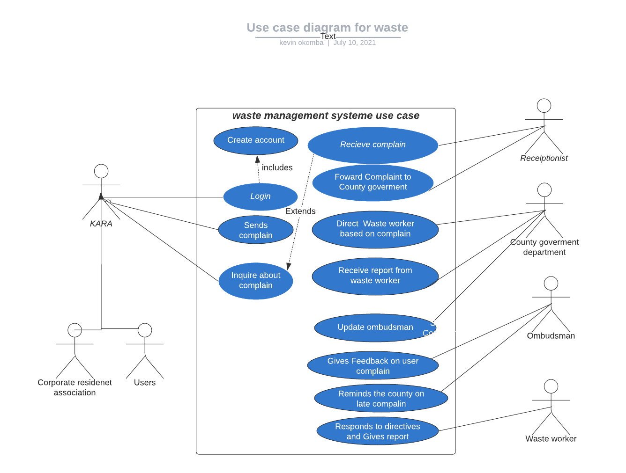

**Web UI.**

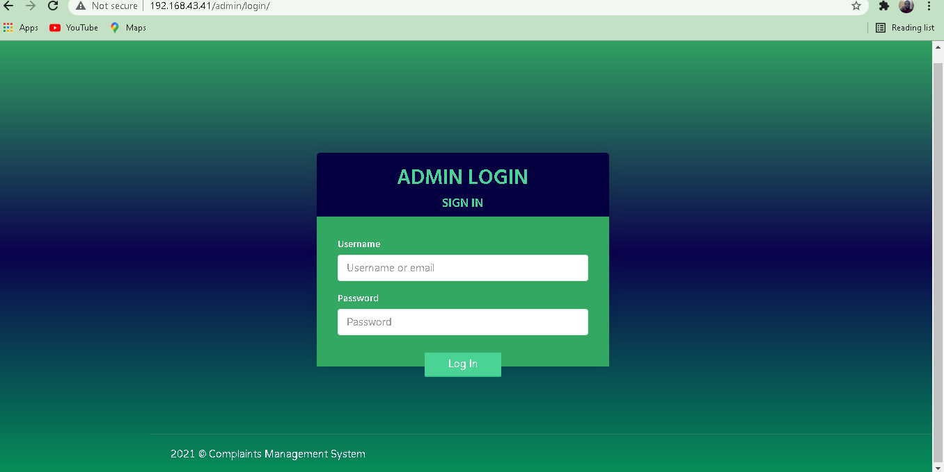

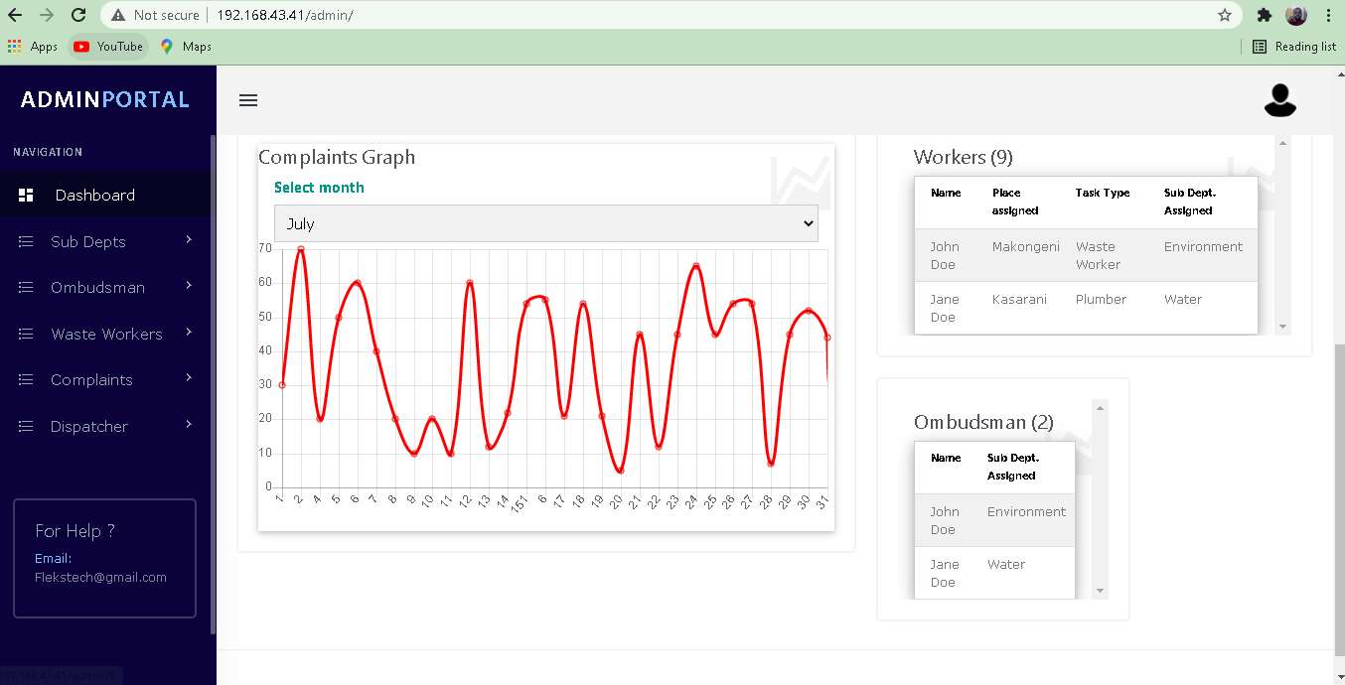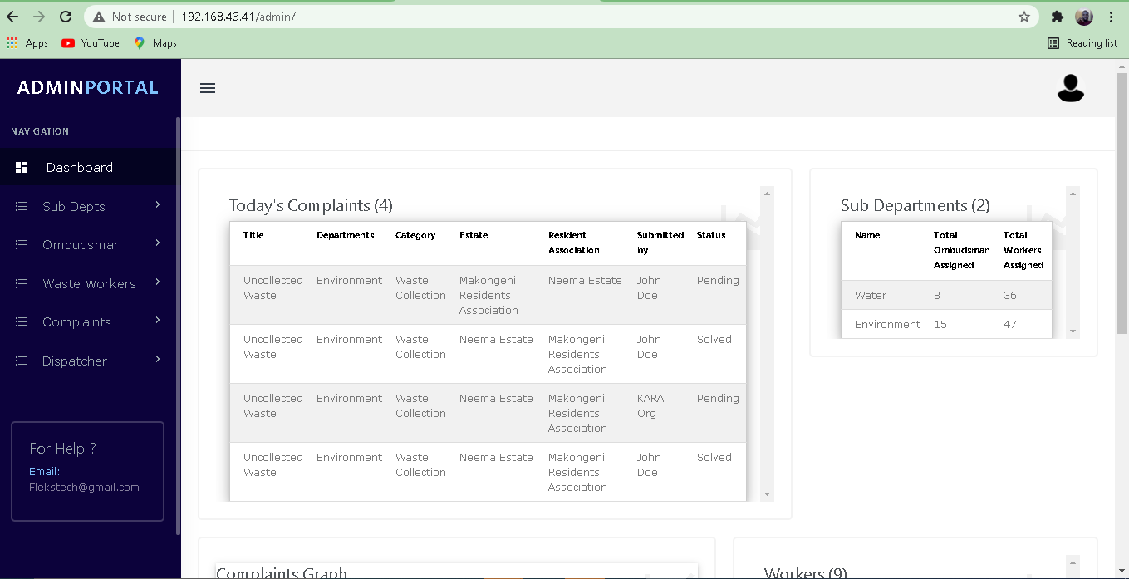

**App UI.**

|  |  |
| --- | --- |
| C:\Users\KEVIN\Desktop\County gvmt web ui\signup.PNG | C:\Users\KEVIN\Desktop\County gvmt web ui\app login.PNG |

|  |  |
| --- | --- |
| C:\Users\KEVIN\Desktop\County gvmt web ui\user app dashboard.PNG | C:\Users\KEVIN\Desktop\County gvmt web ui\reporting ne issue.PNG |

|  |  |
| --- | --- |
| C:\Users\KEVIN\Desktop\County gvmt web ui\Follow up.PNG | C:\Users\KEVIN\Desktop\County gvmt web ui\user profile.PNG |

|  |  |  |  |
| --- | --- | --- | --- |
| |  |  | | --- | --- | | C:\Users\KEVIN\Desktop\County gvmt web ui\chat area.PNG | C:\Users\KEVIN\Desktop\County gvmt web ui\worker task page.PNG | |  |

|  |  |
| --- | --- |
| C:\Users\KEVIN\Desktop\County gvmt web ui\task page.PNG | C:\Users\KEVIN\Desktop\County gvmt web ui\push notification.PNG |

**METHODOLOGY**

**3.1 System development methodology.**

Waste management system is detailed, and require careful decision making in choosing appropriate system development methodology. Taking in note the size of the system we decided to go with the incremental development method to help us achieve objectives as outlined in the TOR documentation. We adopted to incremental development method because it is easier to manage during iteration, errors are easy to identify, easy to test and debug, flexible and more important functionalities can be achieved at an early stage.

The task shall begin by identifying the requirements of all the elements of the waste management as highlighted in the TOR and then allocating subset of these requirements to the software.

**Below is the diagrammatic illustration of the incremental methodology.**

Build 1 Build 2 Build 3

Testing

Implementation

Design

Coding

Testing

Testing

Implementation

Implementation

Design

Design

Coding

Coding

Analysis

*Figure 1. Incremental methodology*

**Phases of the incremental methodology:**

**Requirement analysis:**

Requirements and specification of the system are collected. These requirements are important for better understanding on how to come up with the system. These requirements ranges from business requirements, user requirements and system requirements. For the waste management system, these requirements are extracted from the TOR documentation.

**Design.**

Design is simply conceptualizing, framing, implementing and commissioning the system under development. In the design phase, the Waste management requirements are revisited and increment deduced. The new component is drawn as a wireframe and its functionality discussed for the most part. This makes it easy to write the code.

**Coding**

Coding of the actual software is done in this stage. Functionality is implemented at the coding stage and the expectation should be met and optimized in this level as specified in the requirements. Integration and linking of workable activities in the waste management system are the factors we considered at this phase.

**Testing**

Once the system is coded, it goes through the testing phase. The main objective of the testing is to handle verification and validation of the waste management system. In most cases, testing is a continuous process until the system meets its objectives. The waste management system users does the white-box testing as the developer does black box testing on our side.

**Implementation**

The implementation phase enable the coding phase of the development system. It involves the final coding that designs the designing and development phase and test functionality in the testing phase. After completion of this phase, most functionalities of the Waste management system should be working and upgraded to the final system.